CarelonRx Profile Settings

It is important to make sure that your profile is set up correctly when you are taking CarelonRx calls.

Your profile in theSource should look like this when properly built:

Commercial/Medicaid | Medicare | Commercial/Medicare/Medicaid
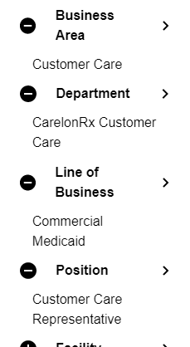 | 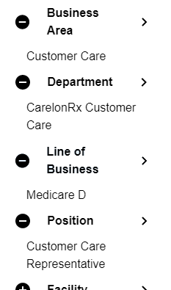 | 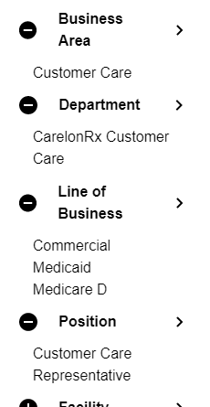
Please note, CarelonRx is not in the Line of Business section.

If you need to make a permanent change to your profile, refer to the Edit a Current Profile section of theSource - Profile Settings Reference Guide (Personal Settings).

Top of the Document
Not To Be Reproduced Or Disclosed to Others Without Prior Written Approval
ELECTRONIC DATA = OFFICIAL VERSION / PAPER COPY = INFORMATIONAL ONLY

